Annual Encounter & General Assembly 2023
St. Justinus, Fribourg (Switzerland), 5th – 7th July 2023

“Between security and risk: ways to open doors for refugee students in Europe”

Dear friends, dear members,

I am happy to invite all of you to the Annual Encounter & General Assembly SECIS 2023 which will take place in Fribourg from Wednesday 5th to Friday 7th July 2023. The programme is as follows:

Wednesday 5th July 2023

15h Welcome in Saint Justinus (Fribourg)
15.30h Report: The status quaestionis on the situation of student refugees in each country (data from the survey sent in March 2023 to different institutions)
19h Dinner
Night visit to the city of Fribourg

Thursday 6th July 2023
9h Presentation of Saint Justinus and meeting with Rt. Rev. Charles Morerod OP, bishop of LGF
13h Lunch
15h Input from Switzerland, student refugees, etc.
19h Dinner

Friday 7th July 2023
9h SECIS General Assembly 2023
13h End of the Annual Encounter and General Assembly

To participate to the meeting, please fill up the registration form attached.
For SECIS members your subscription (200€) is intended to pay the cost of accommodation and meals. Only the travel is therefore at your own expense.

Looking forward seeing you!
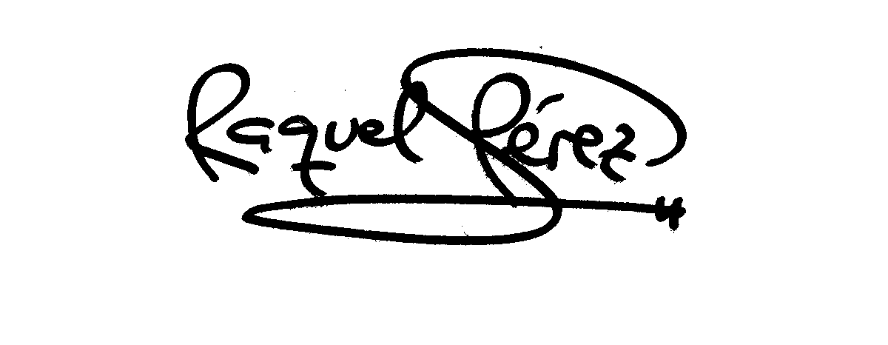
Sincerely yours,

Raquel Pérez, chairwoman of SECIS

REGISTRATION FORM
Kindly send it once filled to pierre.devos@unamur.be with copy to mc@justinus.ch

If possible, attach your SECIS payment (200€) done to:

TRIODOS BANK
Rue Haute 139/3 – 1000 Bruxelles (Belgium)
BIC: TRIOBEBB XXX
IBAN: BE94 5230 8139 6314

Name & Surname:
Institution:
Country:
Email:
Mobile phone:

Particular requests (allergies, etc.):

Date & Approximate arrival time to St. Justinus:
Date & Approximate departure time from St. Justinus:

Thanks for filling this form!

